 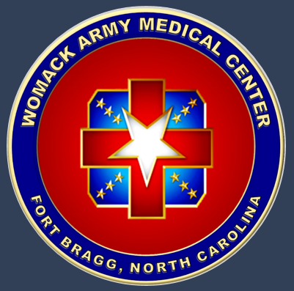

**COL Tyler Harris**

Surgical Specialty Advisor, Army Medical Central Simulation Committee; Orthopaedic Hand Surgeon

*Womack Army Medical Center, Fort Bragg, North Carolina, USA*

*Uniformed Services University of the Health Sciences, Bethesda, Maryland, USA*

COL Harris serves as the surgical specialty advisor and past vice-chair of the

US Army Medical Central Simulation Committee. He is an Orthopaedic Hand Surgeon at Womack Army Medical Center, where he engages research to improve combat medical support for anticipated multi-domain operations. He completed his MD studies, orthopaedic surgery residency, and hand surgery fellowship at Loma Linda University in Loma Linda, California, USA. He served as Chief, Flight Medicine at the Air Force Flight Test Center, Edwards Air Force Base, California, USA, where he performed flight test operations with the Special Operations Combined Test Force. He was Air Force Material Command Flight Surgeon of the Year, for work modifying the AC130-U Gunship to increase combat aircrew effectiveness. He recovered multiple Space Shuttle Missions as a NASA trained Flight Surgeon, and was Deputy Crew Surgeon for STS-55, where he examined astronauts post flight. COL Harris managed multiple mass casualty events during his five prior combat zone deployments, and was awarded the Combat Medical Badge. His publications establish him as a leader in augmented reality telestration for damage control surgery. He has provided pre-deployment training and advises on future medical operations for Special Forces.